Project Report Checkpoint 1: Predicting Food-at-Home Monthly Prices
CS 171 — Introduction to Machine Learning
A Regression Study Using the USDA F-MAP Dataset
Team 1 — Arushi Nirmal, Nathan Montero, Suparn Posina

Contents
1 - Problem Framing 3
2 - Dataset 3
3 - Exploratory Data Analysis 3
4 - Preprocessing and Feature Engineering 5
5 - Evaluation Split 5
6 - Baseline, Models, and Training 6
Baseline and Models 6
Loss and Computation 6
7 - Early Results 6
8 - Error Analysis 8
9 - Neural Network Training 10
10 - Preliminary Insights and Next Steps 10
11 - Reproducibility and References 11
Reproducibility 11
References 11

1 - Problem Framing
We study whether the average monthly retail price of a food group can be predicted from its recent price history together with basic context (calendar month, geographic area, and the number of reporting stores). Food prices are a central economic signal, and reliable short-horizon prediction has practical value for consumers planning budgets and for retailers managing pricing and inventory.
The task is supervised regression. The target is Unit_value_mean_wtd, the weighted average unit price of a food group in dollars per 100 grams. Each observation is one (year, month, food group, geographic area) combination, and the model predicts that combination’s price.

2 - Dataset
We use the USDA Economic Research Service Food-at-Home Monthly Area Prices (F-MAP) dataset. It holds 113,400 observations spanning January 2012 through December 2018 (84 months), covering 90 food groups across 15 geographic areas (metro regions plus a National aggregate). It is publicly available from a trusted government source under USDA ERS public-use terms linked at the end in our references page.
Each row has 15 columns: identifiers (Year, Month, food-group code/name, region code/name), purchase aggregates (weighted and unweighted purchase dollars and grams), Number_stores, and several price measures—our target Unit_value_mean_wtd, its standard error, an unweighted mean, and a GEKS price index.

3 - Exploratory Data Analysis
The dataset is complete and clean: 0 missing cells and 0 duplicate (Year, Month, food group, area) keys.
The target is right-skewed (skewness 1.79). Prices range from $0.033 to $3.29 per 100 g, with a mean of $0.596 and a median of $0.460; the gap reflects a long right tail of expensive specialty items (Figure 1). Because of this skew, we report MAE alongside RMSE. Aggregate prices also drift upward over the window — the national monthly average rises from roughly $0.56 in 2012 to about $0.63 by 2018, with mild seasonal wobble (Figure 2). This upward drift is a key reason a naive mean predictor is weak and why chronological validation matters.
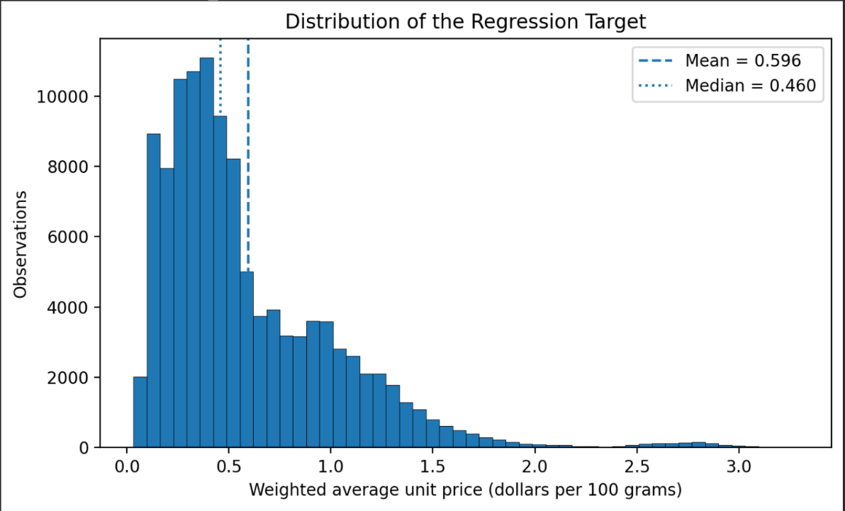
Figure 1. Distribution of the target (right-skewed; mean 0.596, median 0.460).
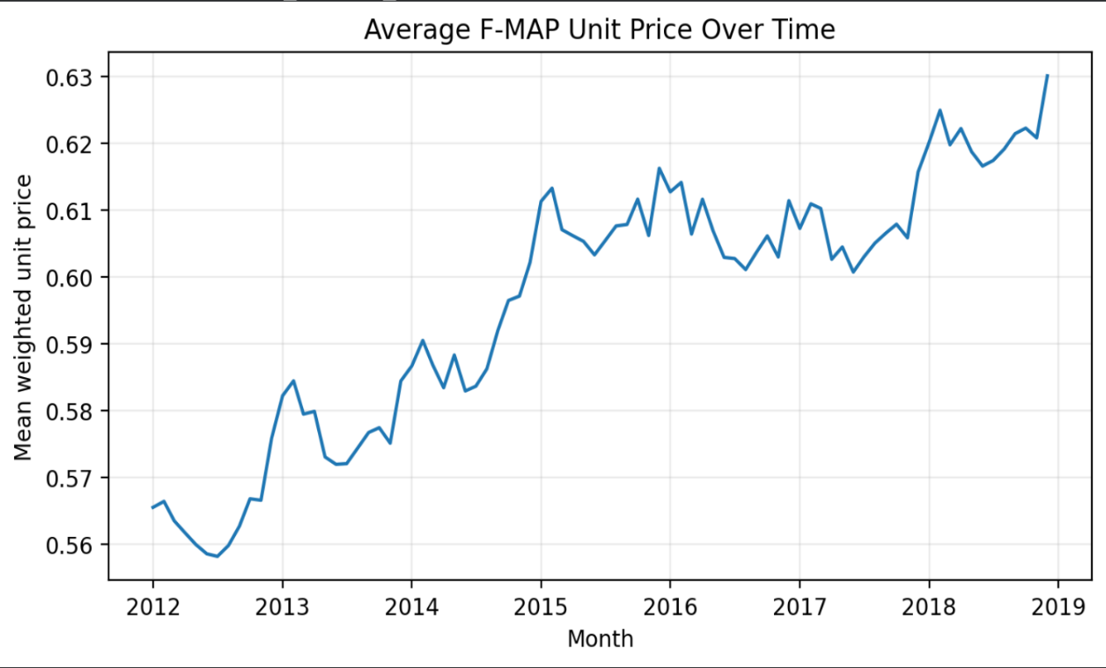
Figure 2. National average F-MAP unit price over time (2012– 2018).

4 - Preprocessing and Feature Engineering
Leakage control. We exclude every column that mechanically encodes the price: the purchase-dollar and purchase-gram aggregates (price = dollars ÷ grams), the unweighted mean price, the target’s standard error, and the GEKS index. These would trivially reveal the answer.
Engineered features. Because prices are highly autocorrelated, we add per-series (food group × area) lag and rolling features: price_lag_1, price_lag_3, price_lag_12 and rolling means price_roll_3, price_roll_12. The calendar month is encoded cyclically as month_sin and month_cos so December and January are treated as adjacent.
Building a 12-month lag consumes the first year of every series, so 2012 becomes a warm-up year that supplies history but is not itself predicted. This reduces the usable set from 113,400 to 97,200 rows (23 columns after adding the 8 engineered ones). The final model inputs are 12 features: food group and area (categorical), Year, Month, month_sin, month_cos, Number_stores, and the five lag/rolling price features. All preprocessing is fit on the training split only.

5 - Evaluation Split
We use a strictly chronological train / validation / test split rather than a random one, because random splitting would leak future information and the lag features would cross the boundary. All results in this checkpoint are on the 2017 validation year; the 2018 test year is reserved and untouched.
Split | Years | Rows
Training | 2013–2016 | 64,800
Validation (used for this checkpoint) | 2017 | 16,200
Reserved test (not touched) | 2018 | 16,200
Table 1. Chronological data split.

6 - Baseline, Models, and Training
Baseline and Models
Our baseline was a mean predictor that always outputs the training-set mean price.
Our models are: Ridge regression (L2-regularized linear), a Decision Tree, a Random Forest, a Multi-Layer Perceptron (MLP), and an LSTM recurrent network that consumes each series’ recent price sequence. Tree and linear models use scikit-learn; the networks use PyTorch.

Loss and Computation
The neural networks minimize mean squared error (MSE). The LSTM trained for 30 epochs on a Google Colab Tesla T4 GPU (CUDA); the MLP was also trained on Colab.
The MLP uses ADAM as the optimizer with a learning rate of 0.001, a batch size of 256, and a maximum of 150 training epochs. Early stopping is enabled with a validation fraction of 15% and training stops if validation performance does not improve for 10 consecutive epochs. The LSTM also uses the ADAM optimizer with a learning rate of 0.001, a weight decay of 0.00001, a training batch size of 512, and a validation batch size of 1024. As stated before, the LSTM trains up to, and did train for 30 epochs with early stopping enabled(patience = 5). The model will restore the model weights from the epoch with the lowest validation loss.

7 - Early Results
All five models beat the mean baseline by a wide margin (Table 2, Figure 3). The baseline gives RMSE 0.459 and R² ≈ 0, while every learned model reaches R² ≈ 0.995. Random Forest is best on the 2017 validation year (RMSE 0.0301, MAE 0.0161, R² 0.9957), narrowly ahead of the LSTM and MLP. Its predictions track true prices tightly along the diagonal across the full range (Figure 4).
Model | RMSE | MAE | R²
Random Forest | 0.0301 | 0.0161 | 0.9957
LSTM | 0.0322 | 0.0175 | 0.9951
MLP | 0.0331 | 0.0218 | 0.9948
Ridge (L2 linear) | 0.0332 | 0.0174 | 0.9948
Decision Tree | 0.0333 | 0.0183 | 0.9947
Mean baseline | 0.4592 | 0.3444 | −0.0006
Table 2. Validation metrics on 2017 (best model shaded).
Honest caveat. These R² values are expected and partly “too easy”: once recent lagged prices are available, next-month price is largely a small adjustment to last month, so price_lag_1 does most of the work (Section 8). This is realistic for short-horizon
forecasting but means model choice should hinge on error in hard categories and on the reserved test set, not on validation R² alone.
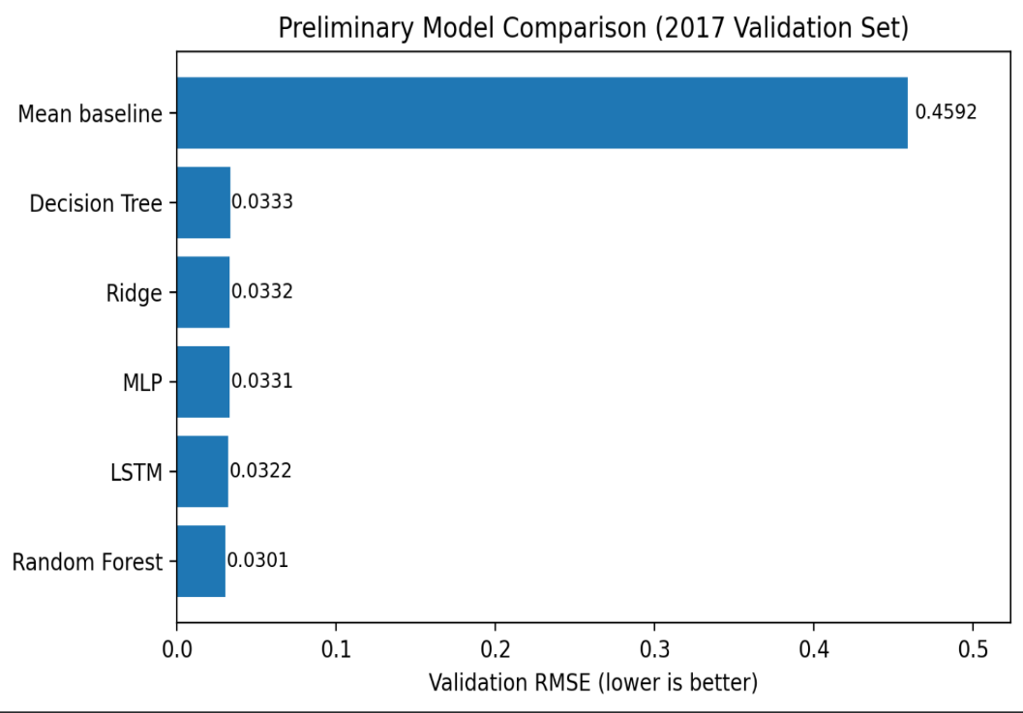
Figure 3. Model comparison (RMSE and MAE, log scale).
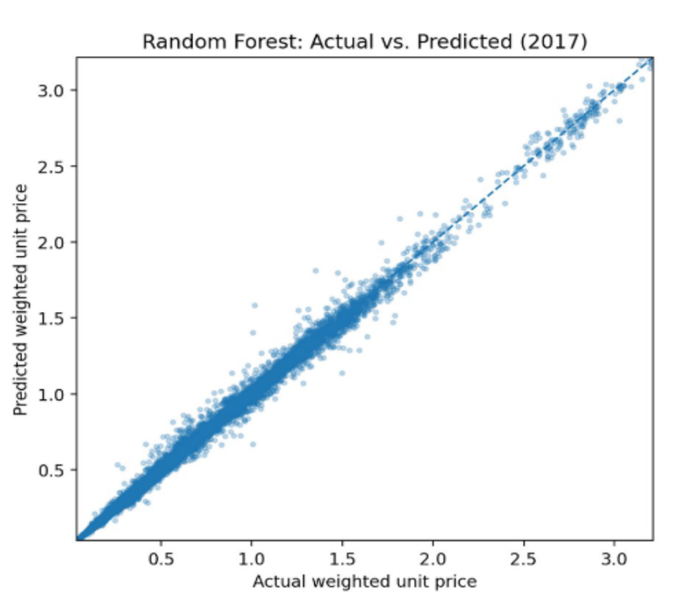
Figure 4. Random Forest predicted vs. actual price in 2017.

8 - Error Analysis
Feature importance confirms the intuition: the Random Forest relies overwhelmingly on price_lag_1, with the rolling means and other lags contributing modestly and the contextual features (area, month, store count) contributing little (Figure 5).
Errors concentrate in volatile or specialty categories. The food groups with the highest validation MAE are vitamins and meal supplements, other starchy vegetables (fresh cut), frozen fish and seafood, infant formula, candy, bacon/sausage/lunch meats, dry spices, and canned meats (Figure 6). These have irregular pricing, promotions, or thinner sampling, where last month’s price is a weaker guide.
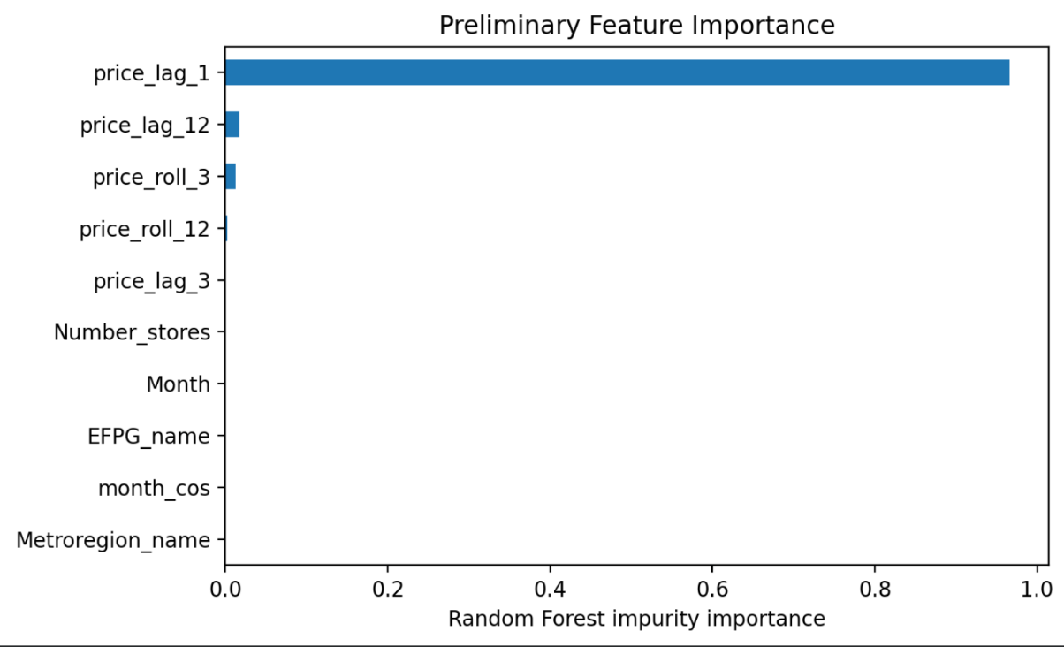
Figure 5. Random Forest feature importance (price_lag_1 dominates).
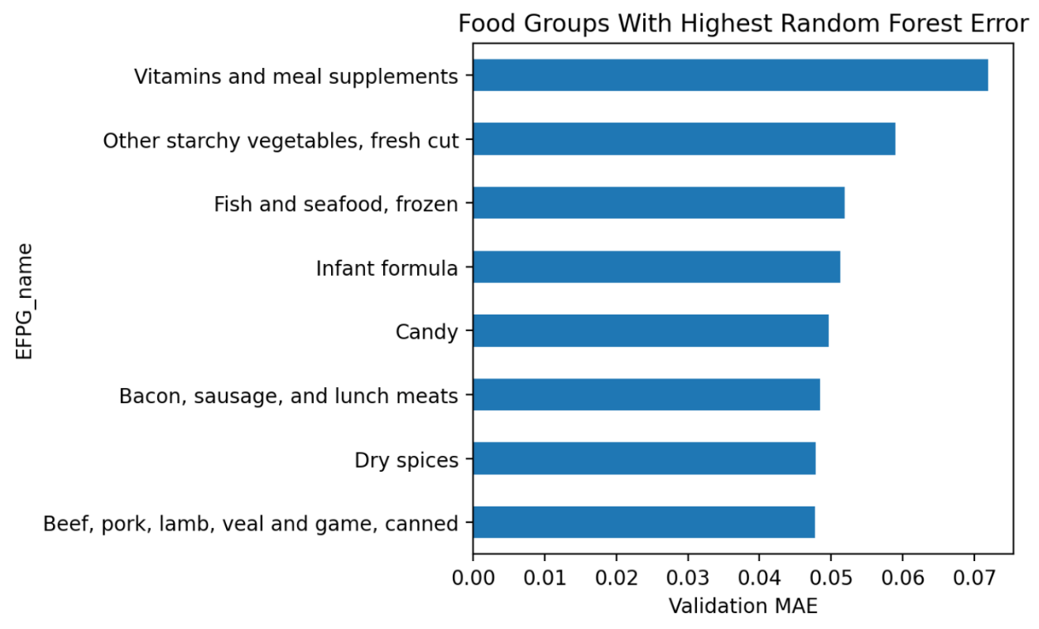
Figure 6. Food groups with the highest validation MAE.

9 - Neural Network Training
Both networks converge smoothly. The MLP’s training loss drops sharply in the first few epochs and flattens (Figure 7). The LSTM’s train and validation MSE both decrease over 30 epochs, with validation MSE settling around 0.0055–0.0064 and no sign of severe overfitting (Figure 8).
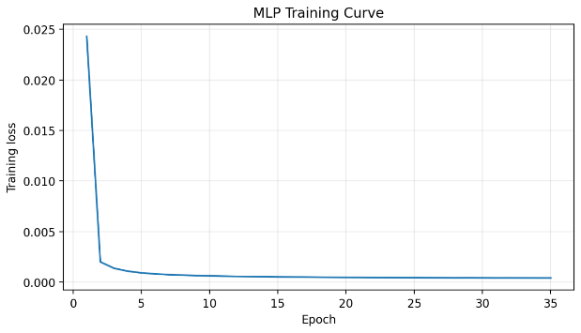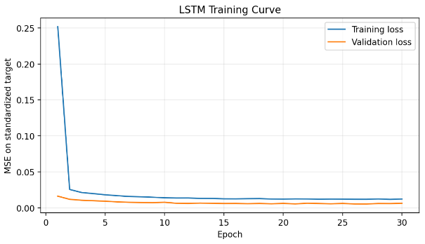Figure 7. MLP training-loss curve. Figure 8. LSTM train vs. validation MSE over 30 epochs.

10 - Preliminary Insights and Next Steps
● Recent price history dominates prediction; contextual features add little at a one-month horizon. ● The mean baseline is easily beaten, confirming the learning task is meaningful.
● Near-identical R² across models means the decisive comparison is error on hard categories and on the held-out test set — not validation R².
Next: hyperparameter tuning with regularization (tree depth / n_estimators, Ridge α, network width, dropout, learning rate) and reporting its effect; full training details (learning rate, batch size, epochs) for both networks; error analysis by region and horizon; possibly predicting price change instead of level to reduce lag_1 dominance; and a single evaluation of the frozen best model on the reserved 2018 test set before the IEEE final paper.

11 - Reproducibility and References

Reproducibility
Code and a runnable Colab notebook are in the team repository; the LSTM was trained on a Colab Tesla T4 GPU.
All experiments were run using a random seed of 42. This ensures reproducibility and is applied to Python’s random module, NumPy, and PyTorch. When CUDA is available, the seed is also applied to all CUDA devices.

References
Repository:
https://github.com/oops408/cs171project
Colab: https://colab.research.google.com/gist/oops408/0075f7e3ad256f783b278253088a1954/cs171_checkpoint1_colab.ipynb
Dataset:
[1] U.S. Department of Agriculture, Economic Research Service. Food-at-Home Monthly Area Prices. 2024. https://www.ers.usda.gov/data-products/food-at-home-monthly-area-prices. Accessed 10 July 2026.

